Magnetism - 05
CLASS 10 - SCIENCE

 | Section A
1 | Match the following with correct response. 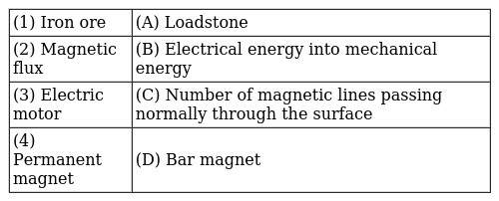  a) 1 - A, 2 - C, 3 - B, 4 - D  b) 1 - B, 2 - D, 3 - A, 4 - C  c) 1 - C, 2 - B, 3 - D, 4 - A  d) 1 - D, 2 - A, 3 - C, 4 - B | [1]
2 | Match the following with correct response.  - S.I unit of magnetic field  - Magnetic field inside the solenoid  - Compass needle  - Solenoid  - Small bar magnet capable of rotating freely  - Tesla  - Temporary magnet  - Uniform  a) 1 - A, 2 - C, 3 - B, 4 - D  b) 1 - C, 2 - B, 3 - D, 4 - A  c) 1 - B, 2 - D, 3 - A, 4 - C  d) 1 - D, 2 - A, 3 - C, 4 - B | [1]
3 | Match the following with correct response. 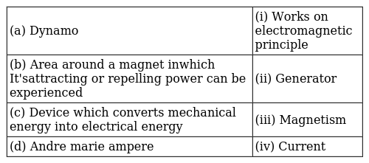  a) (a) - (iv), (b) - (i), (c) - (iii), (d) - (ii)  b) (a) - (ii), (b) - (iv), (c) - (i), (d) - (iii)  c) (a) - (i), (b) - (iii), (c) - (ii), (d) - (iv)  d) (a) - (iii), (b) - (ii), (c) - (iv), (d) - (i) | [1]
4 | Match the following with correct response. 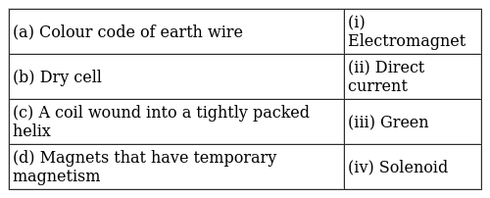  a) (a) - (i), (b) - (iii), (c) - (ii), (d) - (iv)  b) (a) - (iv), (b) - (i), (c) - (iii), (d) - (ii)  c) (a) - (iii), (b) - (ii), (c) - (iv), (d) - (i)  d) (a) - (ii), (b) - (iv), (c) - (i), (d) - (iii) | [1]
5 | Match the following with correct response. 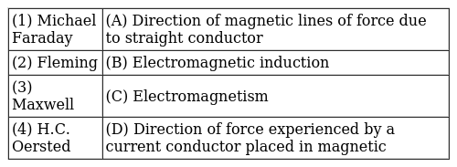  a) 1 - C, 2 - B, 3 - D, 4 - A  b) 1 - D, 2 - A, 3 - C, 4 - B  c) 1 - A, 2 - C, 3 - B, 4 - D  d) 1 - B, 2 - D, 3 - A, 4 - C | [1]
6 | Match the following with correct response. 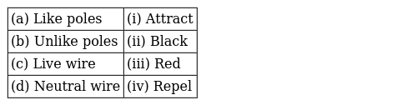  a) (a) - (iii), (b) - (ii), (c) - (iv), (d) - (i)  b) (a) - (i), (b) - (iii), (c) - (ii), (d) - (iv)  c) (a) - (ii), (b) - (iv), (c) - (i), (d) - (iii)  d) (a) - (iv), (b) - (i), (c) - (iii), (d) - (ii) | [1]
 | Section B
7 | The magnetic field lines inside a long current - carrying solenoid are nearly ________.  a) Straight  b) Elliptical  c) Parabolic  d) Circular | [1]
8 | When the main switch of the house circuit is put off, it disconnects the _________  a) Earth wire  b) Live wire  c) Live wire and Neutral wire  d) None of these | [1]
9 | The magnetic axis of earth makes an angle of _________ with geographic axis of earth.  a) 16$​^{o}$  b) 17$​^{o}$  c) 20$​^{o}$  d) 18$​^{o}$ | [1]
 | Section C
10 | Why does a short circuit lead to the fuse wire burning? Which of the following is the correct reason?  - When live wire comes in contact with the neutral line.  - When the current in the circuit abruptly increases.  a) Neither A nor B  b) Only A  c) Only B  d) Both Aand B | [1]
11 | Statement A: H. C. Oersted, a Danesh physicist first noticed the magnetic effect of electric current. Statement B: The strength of the magnetic field is indicated by the closeness of the field lines. Which of the following statement is true?  a) Statement A is true, B is false  b) Statement B is true, A is false  c) Both the statement A and B are true  d) Both statements A and B are false | [1]
12 | Statement A : The magnetic field producesa current in a straight wire that has no poles. Statement B : Like poles of magnets repel each other. Which of the following statement is true?  a) Statement B is true, A is false  b) Statement A is true, B is false  c) Both the statement A and B are true  d) Both statement A and B are false | [1]
 | Section D
13 | Which of the following sentences is correct about Overloading?  a) Overloading can occur when the live wire and the neutral wire come into direct contact.  b) Overloading is caused by connecting too many appliances to a single socket.  c) Overloading can occur due to an accidental hike in the supply voltage.  d) All of these | [1]
14 | Choose the incorrect statement from the following regarding magnetic lines of field  a) The direction of the magnetic field at a point is taken to be the direction in which the north pole of a magnetic compass needle points  b) If magnetic field lines are parallel and equidistant, they represent zero - field strength  c) Magnetic field lines are closed curves  d) The relative strength of the magnetic field is shown by the degree of closeness of the field lines | [1]
15 | Which of following statement is not correct about electric fuseA. It is always connected in live wire B. It is always connected in the end of the circuit C. Thinner the fuse wire, greater is its current capacity D. Its current capacity must be less than the maximum current  a) B and C  b) A and B  c) A and C  d) A, B, C and D | [1]
16 | For current in a long straight solenoid N - and S - poles are created at the two ends. Among the following statements, the incorrect statement is  a) The pattern of the magnetic field associated with the solenoid is different from the pattern of the magnetic field around a bar magnet  b) The strong magnetic field produced inside the solenoid can be used to magnetize a piece of a magnetic material like soft iron when placed inside the coil  c) The N - and S - poles exchange position when the direction of current through the solenoid is reversed  d) The field lines inside the solenoid are in the form of straight lines which indicates that the magnetic field is the same at all points inside the solenoid | [1]
17 | Which one of the following is correct -  - Fuse wire is an alloy of tin and lead  - Switch is always connected to live wire  - Alternate current is unidirectional  - Higher is the value of current flow, weaker is the magnetic field  a) B and C  b) A and C  c) A and B  d) A, B, C and D | [1]
18 | Find the incorrect statement  - Field lines emerge from the south pole and merge at north pole.  - Magnetic field lines can intersect each other.  - A wire with a red insulation is usually the neutral wire of an electric supply.  - All of these  a) D  b) C  c) A  d) B | [1]
19 | For a current in a long straight solenoid, N and S poles are created at the two ends. Among the following statements, the incorrect statement is:  - The magnetic field lines inside the solenoid are in the form of straight lines, which indicates that the magnetic field is uniform at all points inside the solenoid.  - The strong magnetic field produced inside the solenoid can magnetize the soft iron placed inside it.  - The pattern of the magnetic field associated with a current carrying solenoid is different from the pattern of the magnetic field around a bar magnet.  - The N and S poles exchange positions when the direction of current through the solenoid is reversed.  a) Statement (c) is incorrect.  b) Statement (d) is incorrect.  c) Statement (b) is incorrect.  d) Statement (a) is incorrect. | [1]
20 | Choose the incorrect statement  a) The difference between the direct and alternating currents is that the direct current always flows in one direction, whereas the alternating current reverses its direction periodically  b) Fleming’s right - hand rule is a simple rule to know the direction of induced current  c) The right - hand thumb rule is used to find the direction of magnetic fields due to current carrying conductors  d) In India, the AC changes direction after every$\frac{1}{50}$ second | [1]
21 | Which of the following is correct?  - A field lines forms a closed loop.  - Neutral wire is always at zero voltage.  - Heat loss in DC is less than AC.  - Electric fuse is a current generating device.  a) A and C  b) A, B, C and D  c) B and D  d) A, B and C | [1]
22 | Pick out the incorrect statement about magnetic lines of force.  a) Magnetic lines of force are far away .from each other at the poles.  b) Magnetic lines of force closed continuous curves.  c) No two magnetic lines of force can intersect each other.  d) Magnetic lines of forces start from the North Pole and end on the South Pole. | [1]
 | Section E
23 | Electrical resistivities of some substances, in ohm meter, at 20 °C are given as follows : 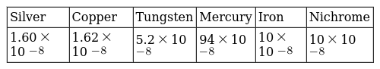  Which substance is preferred to be used for electrical transmission lines?  a) Tungsten  b) Iron  c) Silver  d) Nichrome | [1]
 | Section F
24 | Consider when a hoop shaped coil which has a radius of 80 cm and consists of 30 turns is present in a consistent magnetic field. The current flowing through the coil is 15 A, in presence of magnetic field determine the mean force of the negative particle in the coil (Given cross sectional area = 10$​^{−3}$ m $​^{2}$ ; electron density = 10 $​^{21}$ m $​^{−3}$ ).  a) 12$×$ 10 $​^{−25}$ N  b) 12$×$ 10 $​^{−18}$ N  c) 12$×$ 10 $​^{−20}$ N  d) 12$×$ 10 $​^{−12}$ N | [1]
 | Section G
25 | What is magnetic effect of electric current? | [2]
26 | Give reasons for the following:  - There is either a convergence or a divergence of magnetic field lines near the ends of a current - carrying straight solenoid.  - The current - carrying solenoid when suspended freely rests along a particular direction.  - The burnt - out fuse should be replaced by another fuse of identical rating. | [2]
27 | It is established that an electric current through a metallic conductor produces a magnetic field around it. Is there a similar magnetic field produced around a thin beam of moving  - alpha particles  - neutrons?  Justify your answer. | [2]
28 | Explain the meaning of overloading of an electrical circuit. List two possible causes due to which overloading may occur in household circuits. Write one preventive measure that should be taken to avoid overloading of domestic circuits. | [2]
29 | What is a solenoid? Draw a diagram to show the pattern of magnetic field around a current carrying solenoid. Name the region of uniform magnetic field. | [2]
30 | What is the role of fuse used in series with any electrical appliance? Why should a fuse with defined rating not be replaced by one with a larger rating? | [2]
31 | Meena draws magnetic field lines of field close to the axis of a current carrying circular loop. As she moves away from the centre of the circular loop she observes that the lines keep on diverging. How will you explain her observation? | [2]
32 | State and define S.I unit of magnetic field? | [2]
33 | List two factors on which the strength of magnetic field at a point due to a current carrying straight conductor depends. State the rule that determines the direction of magnetic field produced in this case. | [2]
34 | A house has main fuse rating of 5 A. Three lamps each of 100 W and three CFL’s each of 40 W are used simultaneously. Find :  - the current drawn from the mains of 220 V, and  - the number of additional CFL’s each of 40 W which can also be lighted? | [2]
35 | A house has a main fuse of 5 Arating, 3 bulbs each of 100 W and 8 tube lights each of 40 W are used simultaneously. Calculate :  - the current drawn from the mains of 220 V and  - the number of additional bulbs each of the 60 W which can also be lighted? | [2]
36 | (a) Define the term current rating of an electric fuse? (b) Name the material used to make electric fuse? (c) Name two safety measure commonly used in electric circuit and appliances? | [2]
37 | Which of the following fuse ratings would be suitable for an electric motor of power 3 kW, if it is operated at 220 V supply? (5 A, 10 A, 12 A, 15 A) | [2]
38 | - A straight cylindrical conductor is suspended with its axis perpendicular to the magnetic field of a horse - shoe magnet. The conductor gets displaced towards left when a current is passed through it. What will happen to the displacement of the conductor if the  - current through it is increased?  - horse - shoe magnet is replaced by another stronger horse - shoe magnet?  - direction of current through it is reversed?  - Name and state the rule for determining the direction of force on a current carrying conductor in a magnetic field. | [2]
39 | Consider a circular loop of wire lying in the plane of the table. Let the current pass through the loop in the clockwise direction. Apply right - hand rule to find out the direction of the magnetic field inside and outside the loop. | [2]
40 | Two coils of insulated copper wire are wound over a non - conducting cylinder as shown. Coil 1 has comparative large number of turns. State your observations, when 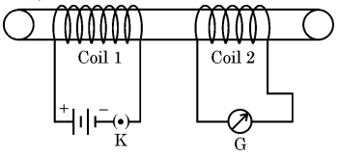  - Key K is closed  - Key K is opened  Give the reason for each of your observations. | [2]
41 | Why is the earth pin in a three pin plug thicker and longer than the other two pins? | [2]
42 | Why don’t two magnetic lines of force intersect each other ? | [2]
43 | What are magnetic field lines? List two characteristic properties of these lines. | [2]
44 | (a) What is a short circuit?(b) What is overloading? How can you avoid overloading? | [2]
45 | List four sources of magnetic field. | [2]
46 | What is meant by short - circuiting ? | [2]
47 | As shown in the diagram an aluminium rod AB is suspended horizontally between the two poles of a strong horse shoe magnet in such a way that the axis of rod is horizontal and the direction of the magnetic field is vertically upward. The rod is connected in series with a battery and a key. 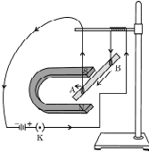  State giving reason:  - What is observed when a current is passed through the aluminum rod from end B to end A?  - What change is observed in a situation in which the axis of the rod ’AB’ is moved and aligned parallel to the magnetic field and current is passed in the rod in the same direction? OR Magnetic field is a physical quantity that has both direction and magnitude. How can this statement be proved with the help of magnetic field lines of a bar magnet? | [2]
48 | How does the strength of magnetic field due to a current carrying conductor depend upon  - distance from the conductor?  - current flowing through the conductor? | [2]
49 | What are magnetic field lines? How is the direction of a magnetic field at a point determined? Mention two important properties of magnetic field lines. | [2]
50 | Given below are three diagrams showing entry of an electron in a magnetic field. Identify the case in which the force on electron will be maximum and minimum respectively. Give reason for your answer. Find the direction of maximum force acting on electron. 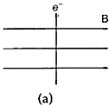  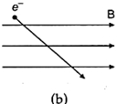  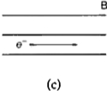 | [2]
51 | It is established that an electric current through a metallic conductor produces a magnetic field around it. Is there a similar magnetic field produced around a thin beam of moving  - $α$ - particles,  - neutrons? Justify your answer. | [2]
52 | State Fleming’s left - hand rule. | [2]
53 | A current carrying conductor is placed perpendicular to the uniform magnetic field. What happens to displacement of the conductor if(i) Amount of current increases (ii) If horse shoe magnet is replaced by a weak horse shoe magnet. | [2]
54 | For the current carrying solenoid as shown, draw magnetic field lines and give reason to explain that out of the three points A, B and C, at which point the field strength is maximum and at which point it is minimum? 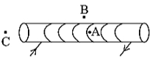 | [2]
55 | What are hazards of electricity ? | [2]
56 | State the condition in each case of the magnitude of force on a current carrying conductor placed in a magnetic field to be  - zero and  - maximum | [2]
57 | - Why is an alternating current (A.C.) considered to be advantageous over direct current (D.C.) for the long - distance transmission of electric power?  - How is the type of current used in household supply different from the one given by a battery of dry cells?  - How does an electric fuse prevent the electric circuit and the appliances from a possible damage due to short - circuiting or overloading. | [2]
58 | The magnetic field in a given region is constant. Draw a diagram to represent it. | [2]
59 | Why does a current carrying conductor kept in a magnetic field experience force? What is the direction of force acting on the conductor? | [2]
60 | - Name and state the rule to determine the direction of force experienced by a current carrying straight conductor placed in a uniform magnetic field which is perpendicular to it.  - An alpha particle while passing through a magnetic field gets projected towards north. In which direction will an electron project when it passes through the same magnetic field? | [2]
61 | Explain what is short circuiting and overloading in an electric supply ? | [2]
62 | A fuse is rated 15 A. Can it be used with an electric heater of rating 3 kW, 220 V? | [2]
63 | Compare the permanent magnet and an electromagnet. | [2]
64 | What is an electromagnet? Draw a circuit diagram to show how a soft iron piece can be transformed into an electromagnet. | [2]
65 | Why does a compass needle show deflection when brought near a bar magnet? | [2]
66 | Why does a current carrying freely suspended solenoid rest along a particular direction? State the direction in which it rests. | [2]
67 | State the inference drawn about the direction of the magnetic field lines on the basis of these diagrams. | [2]
68 | The diagram shows a current - carrying coil passing through a cardboard sheet. Draw three magnetic lines of force on the board. State two factors on which magnitude of magnetic field at the centre depends. 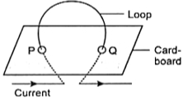 | [2]
69 | What is the function of an earth wire? Why is if necessary to earth metallic casing of electric appliance? | [2]
70 | Kanchi draws magnetic field lines of field close to the axis of a current carrying circular loop. As she moves away from the centre of the circular loop she observes that the lines keep on diverging. How will you explain her observation? | [2]
71 | What kind of magnetic field is produced by a current carrying solenoid? | [2]
72 | What does the direction of thumb indicate in the right - hand thumb rule. In what way this rule is different from Fleming’s left - hand rule? | [2]
73 | Draw the pattern of magnetic field lines around a current carrying straight conductor. How does the strength of the magnetic field produced change:  - with the distance from the conductor?  - with an increase in current in a conductor? | [2]
74 | - What is a solenoid?  - Draw the pattern of magnetic field lines of the magnetic field produced by a solenoid through which a steady current flows. | [2]

